Name: Hamza Bin Adeel
Project: Digital Persuasion & Threat Dashboard - Monitoring Influence, Compliance & Risk

Contents
1. Introduction 3
1.1 The case study 3
1.2 The dataset 3
1.3 Research Questions and Hypotheses 3
2. Data Preparation 4
2.1 Tool and Justification 4
2.2 Preprocessing Steps 5
2.3 Limitations 5
3. Exploratory Analysis 6
3.1 Descriptive Statistics and Message Length Analysis 6
3.2 Urgency Cue Analysis 7
3.3 Lexical Analysis (Unigrams and Bigrams) 7
4. Critique of AI-Generated Insights 8
5. Visualisation 10
5.1 Dashboard Construction 10
5.2 Design Principles 12
5.3 Creation of Visualisation 13
6. Personal Reflection and Synthesis 15
7. Conclusion 16
References 17
Appendices 19
Appendix A 19
Appendix B 19
Urgency Cue Dictionary 19
Appendix C 23
Prompt for Persuasion Mechanisms 23
Prompts for Structure and Language 24
Prompts to suggest Exploratory Analysis Directions and Dashboard Designs 24

Introduction

The Case Study
In the digital age, the convergence of cybersecurity and persuasive communication analysis is an essential organisational requirement (Abdelhamid & Mahmoud Maqableh, 2024). The case study highlights how malicious actors use psychological levers through phishing and social engineering, while persuasive design, behavioural nudging and digital communication strategies are increasingly used to influence user actions. This creates a visibility gap for senior leaders, who seldom have consolidated insights into how urgency or reward-based cues appear within malicious communication. This assessment aims to help senior leaders prioritise user-trust and awareness interventions and keep an eye on the intersections between cyber threats and persuasive tactics through an interactive dashboard.

The Dataset
The assessment draws upon a dataset obtained through Zenodo (Engineering Ingegneria Informatica Spa, 2025). After download, the dataset is a .xlsx file with two columns that include 624 anonymised English-language messages:
- Corpus: Content of messages (such as emails or SMS).
- Label: Type of message (not-malicious, phishing, malware, scareware, baiting and pretexting).
The dataset is ideal for natural language processing (NLP) methods intended to extract persuasive cues related to urgency and linguistic indicators.

Research Questions and Hypotheses
The following primary research question guides the investigation:
- How do different cybersecurity threat categories differ in their linguistic, structural and persuasion-based characteristics and how can these differences be visualised to support ethical risk monitoring and user-susceptibility assessment for senior leaders?
Three sub-research questions and their corresponding hypotheses provide additional support for the primary research question.
- RQ1: Do various threat types depend on longer narrative structures to appear legitimate and persuade? H1: Phishing messages are longer and more variable in length to appear legitimate and persuade.
- RQ2: Which threat types rely most on urgency to pressure user compliance? H2: Phishing messages have a greater percentage of urgency-related linguistic cues to pressure user compliance.
- RQ3: What lexical patterns make each threat category distinct? H3: Phishing messages use verification-based bigrams and account-related unigrams.

Data Preparation
Before the exploratory analysis, the dataset needed to be thoroughly cleaned. A preliminary examination revealed that the Labels column was empty, whereas the Corpus column, as depicted in Figure 1, contained both the message text and its matching label combined into a single string. There was an obvious problem with the data quality in this structure.
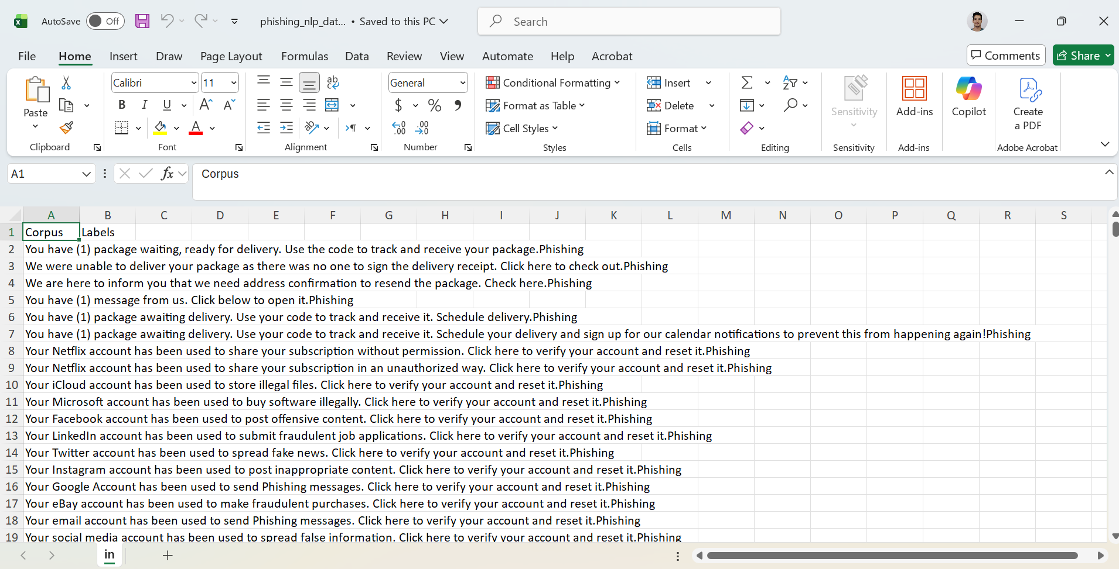
Figure 1 Dataset before data preparation (Source: Self-generated)

Tool and Justification
Python's vast ecosystem for NLP and smooth integration with the dashboard development led to its selection as the main data preparation tool. Python made it possible to record and duplicate all cleaning transformations and its pandas library allowed for effective dataset manipulation (Ranjan et al., 2023). This is in line with the assessment’s requirement that all analytical steps be traceable and that technical proficiency be demonstrated.

Preprocessing Steps
The initial cleaning step involved loading the dataset and separating the combined values in the Corpus column. The data was divided into two new columns, message_text and message_label, using the.str.split() method with a tab delimiter (see Appendix A). Rows with missing or incorrectly parsed values were eliminated by further processing. Following cleaning, each row had a valid label and a clearly separated message and the initial Corpus and blank Labels columns were eliminated. A manual examination of the cleaned dataset revealed that three rows were eliminated since the text lacked a label and therefore, 621 of the 624 rows in the raw file were kept. As seen in Figure 2, a cleaned version of the dataset was saved as phishing_cleaned.xlsx for further analysis.
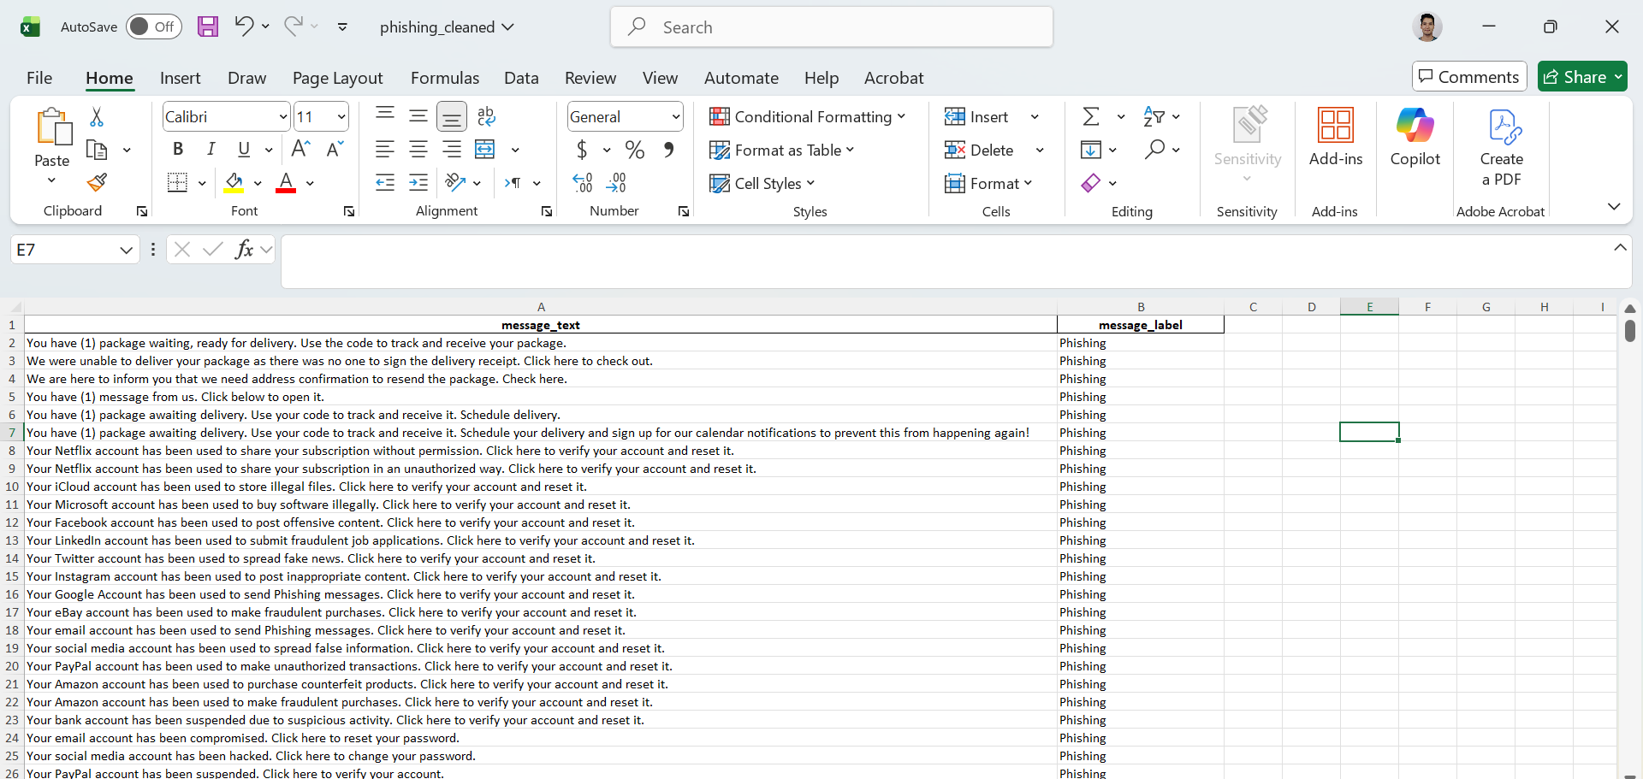
Figure 2 Dataset after data preparation (Source: Self-generated)

Limitations
No restrictions or limitations were faced during the data preparation step, as Python’s flexibility made it possible to successfully address structural problems. The cleaned dataset offered a solid basis for exploratory analysis and visualisation.

Exploratory Analysis
The exploratory analysis explored the linguistic, structural and persuasive nature of the data. (Note: The original label “NOT-Malicious General Class” is kept in the tables, although the dashboard displays this as “Non-malicious” for easier reading.)

Descriptive Statistics and Message Length Analysis
A descriptive summary of the dataset showed the following distribution of messages (see Appendix B, Table 1):
- 171 entries in the NOT-Malicious General Class.
- 114 in Phishing.
- 100 in Scareware.
- 80 in Baiting.
- 78 in Malware and Pretexting.
There are also noticeable structural variations in message length:
- Phishing messages have a significantly higher average word count of 80.54 words per message, with a wide range of 8 to 519 words and a very high standard deviation of 140.65. This suggests that phishing messages are typically longer and more variable.
- Baiting, malware and pretexting messages, on the other hand, are in the middle, averaging between 15 and 24 words.
- Scareware messages are brief, with a mean length of 14.22 words and a minimal standard deviation of 1.4.
- With a mean word count of 23.7, NOT-Malicious General Class messages are moderately long, but they are less dispersed and have a smaller range than phishing messages.
These findings imply that phishing messages use detailed wording. The widespread use of longer structures could be a sign of more intricate narrative framing to increase perceived legitimacy. Phishing messages exhibit a clear structural pattern and are significantly longer and more variable than all other categories. Therefore, the evidence supports H1.

Urgency Cue Analysis
To assess the persuasive elements in the messages, urgency cues were extracted using a manually created dictionary of urgency keywords in Python (see Appendix B, Urgency Cue Dictionary). Differences between categories are evident (see Appendix B, Table 2):
- Phishing messages exhibit the strongest persuasion pattern with, 42.98% messages (49 out of 114 messages) containing urgency cues.
- Pretexting shows a significant percentage of urgency with, 37.18% because these messages involve identity impersonation requiring immediate user verification.
- Baiting shows urgency in 2.5% of messages.
- Malware shows urgency in 8.97% of messages.
- Scareware shows urgency in 13% of messages.
- It's interesting to note that 18.13% of NOT-Malicious messages contain urgency-related terms, but this is primarily due to benign contexts like notifications or reminders.
When looking at the frequency of urgency cues (see Appendix B, Table 3), the following behaviour was observed:
- Phishing messages use urgency cues such as now, verify, immediate and immediately.
- Pretexting messages use urgency cues such as verify and verification.
- Scareware messages use urgency cues such as now, urgent and immediate.
- Baiting, Malware and NOT-Malicious General Class messages exhibit urgency cues such as now.
This pattern demonstrates that urgency is more common in phishing messages with a wider variety of cues. The findings demonstrate that phishing messages have the highest percentage and variety of urgency cues. Therefore, the evidence supports H2.

Lexical Analysis (Unigrams and Bigrams)
The lexical frequency analysis revealed significant variations in the content of messages (see Appendix B, Table 4):
- Phishing messages frequently include unigrams such as account (101), money (78) and click (58), indicating a persuasion strategy based on fear of account activity.
- Scareware messages include unigrams such as download (86), attachment (79) and infected (66), indicating a persuasion strategy based on system vulnerability.
- Malware messages include unigrams which relate to deceptive file delivery such as file (41), attachment (40) and view (32).
- Baiting messages focus heavily on reward-based unigrams, such as free (104), offer (95) and exclusive (62).
- Pretexting messages revolve around impersonation with unigrams such as need (58), customer (47) and password (38).
- NOT-Malicious General Class messages use conversational language with unigrams such as know (30), like (25) and greetings (24).
These insights are enhanced by bigram patterns (see Appendix B, Table 5):
- Phishing messages are focused on authentication and security‐related deception with bigrams such as click verify (27), verify account (27) and account reset (26).
- Scareware bigrams such as download attachment (79), computer infected (53) and restore security (19) emphasise warning and remediation.
- Baiting bigrams such as offer free (95) and free membership (55), highlight reward-based manipulation.
- Pretexting bigrams such as need email (31), customer service (31) and address password (31) support the impersonation theme.
- NOT-Malicious General Class messages again differ, including best regards (17), let know (12) and reply greetings (8) as bigrams.
The lexical analysis confirms that every category uses a unique persuasion method. The analysis also affirms that phishing messages exhibit more frequent verification-based bigrams and dominant account-related unigrams than other threat types. Therefore, the evidence supports H3.

Critique of AI-Generated Insights
Two LLMs were used in the creation of the dashboard, which were accessed via their respective web interfaces:
- Gemini for conceptual and exploratory insight into the dataset.
- ChatGPT for coding the interactive dashboard.
Gemini was used after the dataset was cleaned. The prompts asked Gemini to recommend exploratory analysis insights and dashboard designs (See Appendix C) (Gemini, 2024). Gemini’s answers offered helpful conceptual themes:
- Phishing was framed as authority and impersonation.
- Scareware as fear and intimidation.
- Malware as curiosity.
- Baiting as a lure of reward and exclusivity.
- Pretexting as authority and rapport-building.
- NOT-Malicious General Class as relatability and social context.
In general, these themes supported the exploratory analysis. However, Gemini frequently made numerical claims that, when programmatically analysed, did not match the real insights. For example, the empirical EDA revealed urgency cues in 42.98% of phishing messages and a different distribution across categories, while Gemini claimed that urgency keywords were present in 30.70% of phishing messages. Similarly, Gemini provided generic structural statistics, such as average length characters or 456.7 with a deviation of 793.2 in phishing messages, but the exploratory analysis determined an average phishing length of 80.54 words with high variance. These differences suggest that Gemini’s results are reasonable but not data-bound, necessitating systematic verification against the statistics derived.
For the Python Dash dashboard, ChatGPT was utilised as a coding assistant (ChatGPT, 2025). Complete app structures, including data loading, layout, callbacks and three interconnected visualisations, were requested in the initial prompts. Although the generated code ran successfully, it needed a lot of fine-tuning in terms of colour schemes, heading alignment, font sizes and styles and narrative annotations. The implementation of dropdown filters and the accurate display of bigram count on metric cards required additional prompts. These iterations show that while ChatGPT expedites development, significant human intervention is still required to produce a professional output.
In opinion, the LLMs serve as scaffolding and ideation tools rather than as authoritative analytical engines. Empirical analysis and manual coding were used to test, correct or expand their outputs after they were handled as hypotheses and templates. The strongest insights were found when AI recommendations were critiqued rather than accepting them without question.

Visualisation

Dashboard Construction
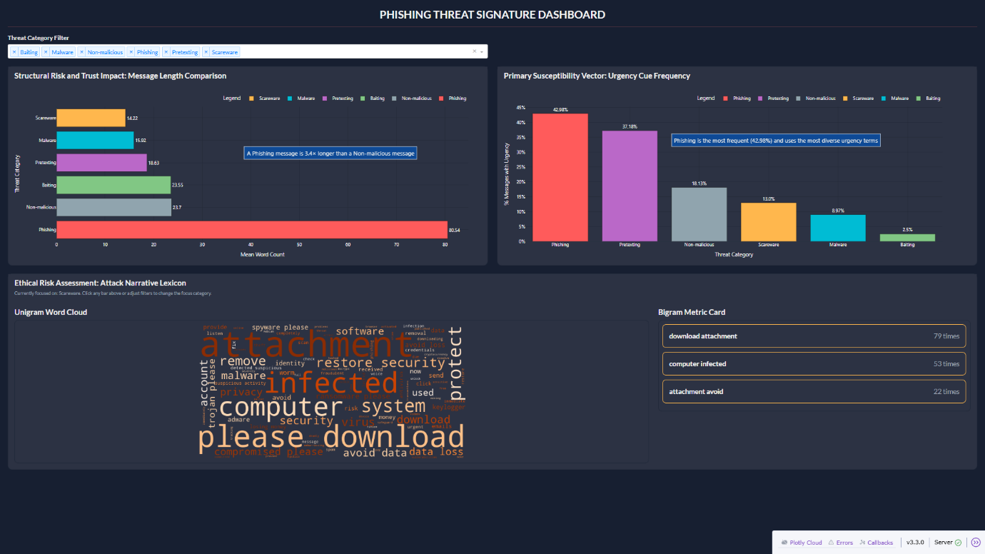
Figure 3 Phishing Threat Signature Dashboard (Source: Self-generated)
The Phishing Threat Signature Dashboard, depicted in Figure 3, was created using a multi-phase technical process that started with raw text data and ended with an interactive interface. The dashboard consists of 3 interconnected visualisations:
- Structural Risk and Trust Impact: Message Length Comparison.
- Primary Susceptibility Vector: Urgency Cue Frequency.
- Ethical Risk Assessment: Attack Narrative Lexicon (Unigram Word Cloud and Bigram Metric Card).
Working together, these visualisations offer a multi-layered analytical viewpoint. The first two visuals display quantitative structural indicators of persuasion, while the third visual highlights linguistic attack patterns and semantic content. The dashboard allows decision-makers to view phishing as a behavioural-linguistic phenomenon motivated by message design, urgency and psychological manipulation in addition to being a cybersecurity threat.
Python Dash is used to provide both processing power and responsive user interfaces. Each of the core libraries fulfils a specific engineering function:
- pandas structures and manipulates the dataset.
- numpy supports numeric operations.
- re handles pattern-based search for urgency cues.
- WordCloud generates image-based text frequency representations.
- CountVectorizer performs linguistic feature extraction.
- plotly.express renders animated and responsive data visualisations.
The code constructs engineered features from raw texts using the code:
df["length_words"] = df["message_text"].str.split().str.len()
This sequence counts tokens after tokenising the message. It converts qualitative text into measurable patterns of behavioural signatures. Similarly, urgency detection relies on a regular-expression pattern using the code:
pattern = r"(" + "|".join([re.escape(term) for term in urgency_terms]) + r")"
df["urgency_count"] = df["message_text"].str.lower().str.count(pattern)
df["is_urgent"] = np.where(df["urgency_count"] > 0, 1, 0)
This looks for urgency cues (see Appendix B, Urgency Cue Dictionary). These occurrences are converted into binary classification by using np.where() to calculate is_urgent. Before the user interacts with the dashboard, the data is combined into precalculated summary tables (length_stats, urgency_stats). Callbacks simply read filtered sets of pre-aggregated data in real time, which do not need dynamic recalculation of statistics. To ensure the stability of the alignment and rational visual hierarchy, the layout is built using dbc.Row and dbc.Col and applying the principles of the grid-based formatting of Bootstrap. This helps avoid visual dominance and orient the eye horizontally due to the creation of the half-screen visual equilibrium of the top two visualisations.
To guarantee uniformity and semantic tone across the dashboard, centralised colour variables are used to achieve the “dark executive” cybersecurity theme using:
DARK_BG = "#171F31"
CARD_BG = "#2c3243"
TEXT_MAIN = "#f5f5f5"
Category-specific colours are defined as:
LABEL_COLOR_MAP = {"Phishing": "#ff5b5b", "Scareware": "#ffb74d", "Malware": "#00bcd4", "Pretexting": "#ba68c8", "Baiting": "#81c784", "Non-malicious": "#90a4ae"}
These colours minimise cognitive switching and support quick visual recognition by ensuring that each category maintains a consistent visual identity across the dashboard.

Design Principles
The dashboard design is cognitively effective and intentionally simple. The dashboard abstracts the risk of cyber persuasion into a visual signal, which can be interpreted, like the length of the bar, colour weight and emphasis of lexical meaning, as per the Munzner framework (Munzner, 2014). It meets the high-level monitoring requirements as opposed to low-level examination.
From the perspective of telling a story, the layout can be likened to a funnel of understanding, where the narrative material is located at the bottom, pressure of urgency on the right and structural complexity on the left side. This aligns with the fact that visualisations are supposed to narrate a story and not merely present data (Cairo, 2013). Textual overlays such as “A phishing message is 3.4x longer than a Non-malicious message” are useful to promote interpretive framing (Shown below in Figure 4).
The dark colour scheme serves practical purposes in addition to being aesthetically pleasing. Cybersecurity dashboards typically have a dark background, particularly in SOC environments (Aparna, 2025). A dark executive theme is chosen for this dashboard owing to the following reasons:
- Low-glare interfaces reduce fatigue.
- High-contrast signals pop visually.
- Dark mode environments mimic real-time cyber-monitoring rooms, where low-light illumination heightens screen-centric visual perception.

Creation of Visualisation
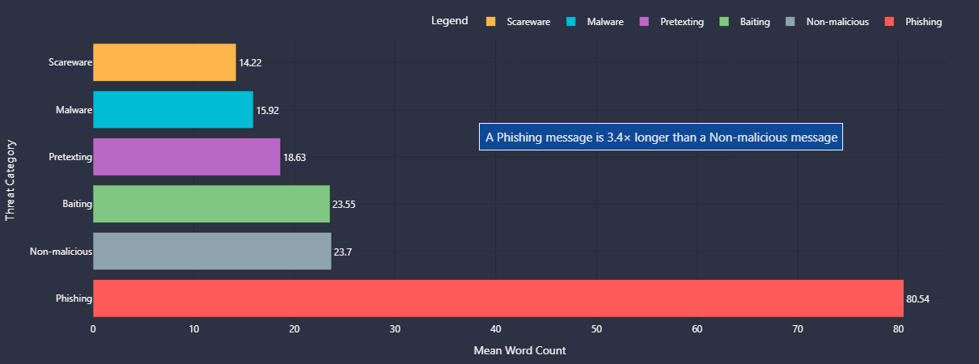
Figure 4 Structural Risk and Trust Impact: Message Length Comparison Visualisation (Source: Self-generated)
The Structural Risk and Trust Impact: Message Length Comparison visual, as shown in Figure 4, highlights the average message length for each threat category, revealing how different attackers rely on varying degrees of linguistic complexity. While shorter messages rely on fast, high-pressure cues, longer messages usually try to establish narrative legitimacy and credibility. This helps senior leaders make decisions related to message formulation by comparing the structural differences in different threat types.
The visual is constructed through the code:
fig = px.bar(data, x="mean_words", y="message_label", orientation="h", color="message_label", color_discrete_map=LABEL_COLOR_MAP, text=(data["prop_urgent"] * 100).round(2).astype(str) + "%")
Plotly is utilised for its hover-inspection and dynamic rendering. As textual categories are easier for human readers to process when they are aligned along a vertical axis, horizontal bars were purposefully chosen instead of vertical ones. Callout annotation was added using:
fig.add_annotation()
Instead of requiring the viewer to deduce significance on their own, this emphasises user-risk interpretation.
This visualisation does not sit in a vacuum; it powers the others. Dash’s callback mechanism enables interactivity. ClickData is used to identify the user’s click on a threat category by:
Input("length-bar", "clickData")
From there, the triggered update is routed to the lexical callback through the code:
def update_lexical_view(length_click, urgency_click, selected_labels):
This means that when a user clicks Scareware or Baiting bar in Visual 1, only Scareware lexical signatures are displayed in the word cloud and bigram cards, as depicted in Figures 5 and 6.
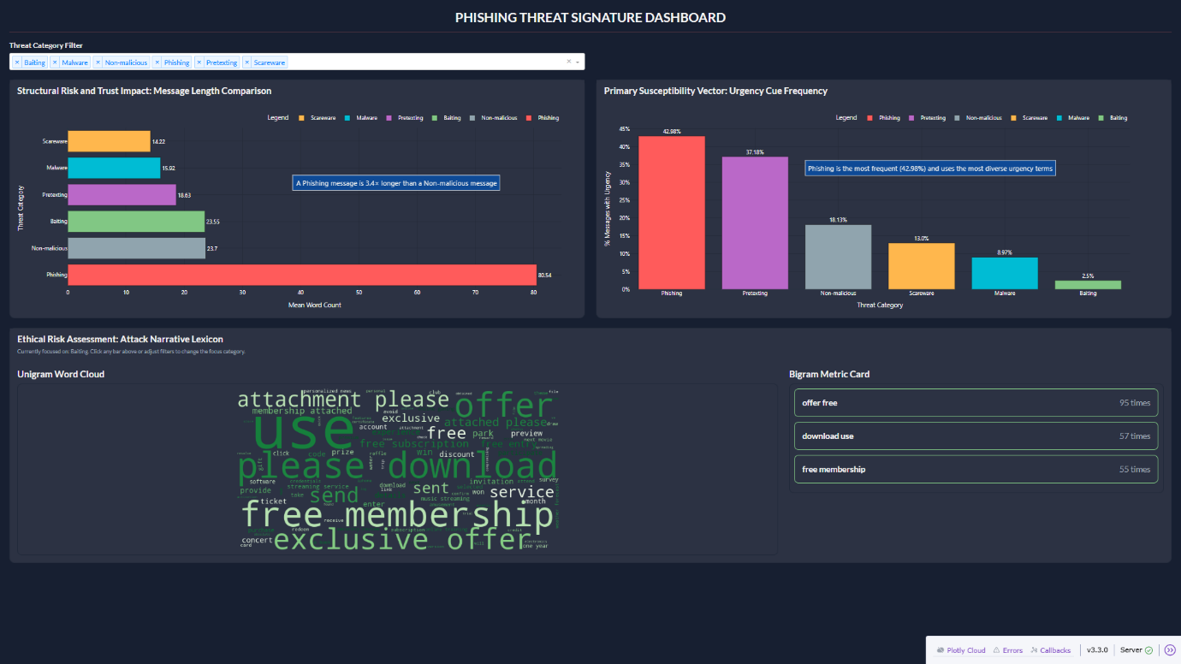
Figure 5 Dashboard when user clicks Baiting (Source: Self-generated)
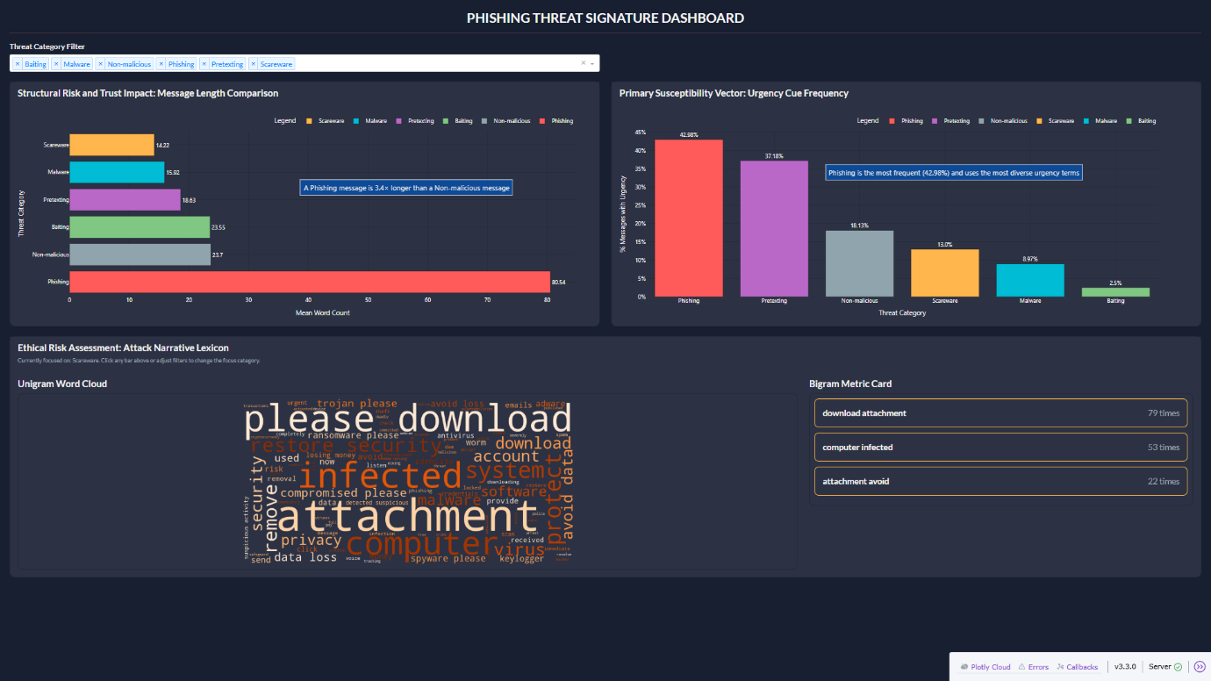
Figure 6 Dashboard when user clicks Scareware (Source: Self-generated)
Additionally, the dropdown filter, as shown in Figure 7, acts as a global constraint layer and is developed through the code:
Input("label-filter", "value")
Figure 7 Threat Category Filter (Source: Self-generated)
If a threat category, like Phishing and Malware, is deselected from the filter, clicking anywhere else won’t bring up the deselected category in other visuals, as depicted in Figure 8.
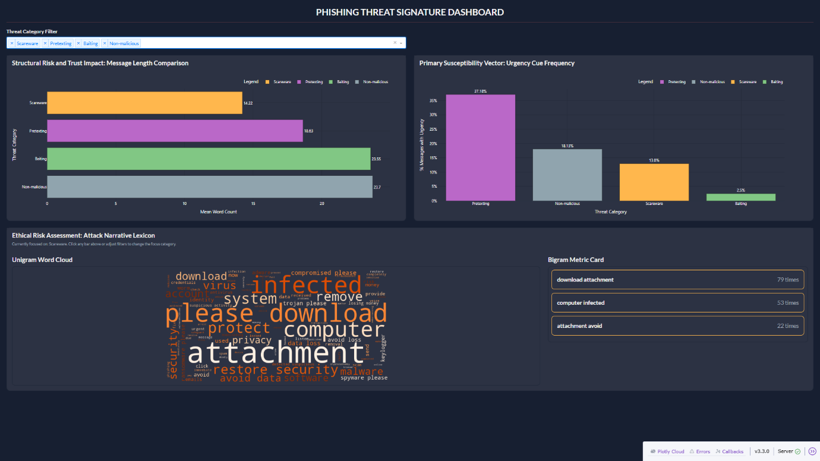
Figure 8 Dashboard after Phishing and Malware are deselected from the filter
The first visualisation thus serves as the analytical anchor of the dashboard.

Personal Reflection and Synthesis
The use of AI tools as an aid for this assessment has enhanced personal knowledge of the limits between algorithm-based assistance and human judgment. Gemini could not come up with insights that were directly informed by the empirical distribution of data but could give thematic accounts of persuasion strategies in threat categories. It connoted degrees of urgency and structural characteristics that were nevertheless generic but seemed sensible. However, the exploratory analysis revealed statistically different trends as opposed to the estimates used by Gemini. This proved that AI can be used to mimic analytical reasoning, but it does not reason based on the data unless it is explicitly restricted by validated numbers. Therefore, the technical insights had to come from the exploratory analysis instead of being based on assumptions provided by AI.
On a parallel note, ChatGPT sped up the process of creating the dashboard but failed to generate a professional output. Intervention and design judgement in accordance with ethical persuasion principles from my annotated bibliography and module literature were necessary for UI styling, layout refinement, filter logic, inter-visual communication and professional annotations. My insistence on accurate depictions and contextual commentary was influenced by Cairo’s idea that “charts are not illustrations but visual arguments” (Town Hall Seattle, 2020).
The persuasive power of images in forming beliefs is highlighted by Pandey et al. (2014), who remind designers to be mindful of implicit framing effects. In line with Laubheimer’s findings that length-based comparisons facilitate quicker and more accurate comprehension, my dashboard employs linear bar charts rather than radial or area-based encodings (Laubheimer, 2017).
Combining these concepts, the dashboard is informative and persuasive as it draws attention to patterns without being manipulative. Although AI expedited procedural steps, a human was ultimately responsible for the interpretive intelligence and ethical framing.

Conclusion
The analysis indicates that the linguistic framework, the use of urgency cues and narrative lexicon of phishing messages are quite distinct compared to other cybersecurity threats. Phishing messages are based on elaborate narrative structures to build legitimacy and authority. They contain a large proportion of urgency cues, which underline time pressure and account risk.
These structural, psychological and narrative understandings are integrated into a dashboard that assists senior leaders to make decisions. Quick pattern identification and enhanced contextual interpretation of persuasive communication strategies are enabled by the dashboard through interactive filtering, annotated comparisons and drill-down lexical exploration. These insights can be used by organisations and top stakeholders to enhance the training of employees, develop communication principles and ensure that digital messages are ethical. In general, effective cybersecurity governance requires not only technical measures but also a complex understanding of the influence of persuasion on people that occurs in malicious messages.

References
Abdelhamid, R. K., & Mahmoud Maqableh. (2024). The Power of Persuasion: Exploring Social Engineering in the Digital Age. Studies in Computational Intelligence, 307–330. https://doi.org/10.1007/978-3-031-61463-7_16
Aparna. (2025, February 28). The Ultimate Guide to Cybersecurity Dashboard UI/UX Design. Aufait UX. https://www.aufaitux.com/blog/cybersecurity-dashboard-ui-ux-design/
Cairo, A. (2013). The functional art: an introduction to information graphics and visualization. New Riders.
ChatGPT. (2025). ChatGPT - Assessment analysis request. ChatGPT. https://chatgpt.com/share/69275730-0858-8007-9914-2cb4a9cefaa0
Engineering Ingegneria Informatica Spa. (2025). Multiclass NLP Dataset for Phishing and Social Engineering Threat Detection. Zenodo. https://doi.org/10.5281/zenodo.15235123
Gemini. (2024). Gemini. Gemini. https://gemini.google.com/share/0c0fe7794943
Laubheimer, P. (2017). Dashboards: Making Charts and Graphs Easier to Understand. Nielsen Norman Group. https://www.nngroup.com/articles/dashboards-preattentive/
Munzner, T. (2014). Visualization analysis & design. Crc Press, Taylor & Francis Group.
Pandey, A. V., Manivannan, A., Nov, O., Satterthwaite, M., & Bertini, E. (2014). The Persuasive Power of Data Visualization. IEEE Transactions on Visualization and Computer Graphics, 20(12), 2211–2220. https://doi.org/10.1109/tvcg.2014.2346419
Ranjan, M., Barot, K., Khairnar, V., Rawal, V., Pimpalgaonkar, A., Saxena, S., & Sattar, A. Md. (2023). Python: Empowering Data Science Applications and Research. Journal of Operating Systems Developement & Trends, 10(1). https://doi.org/10.37591/joosdt.v10i1.576
Town Hall Seattle. (2020, November 25). Alberto Cairo: How Charts Lie and Influence Our Perception of Truth. YouTube. https://www.youtube.com/watch?v=-6stpCiUSWM

Appendices

Appendix A
df[['message_text', 'message_label']] = df['Corpus'].str.split('\t', n=1, expand=True)
df = df.drop(columns=['Corpus', 'Labels'])
df = df.dropna(subset=['message_text', 'message_label'])
df['message_text'] = df['message_text'].str.strip()
df['message_label'] = df['message_label'].str.strip()

Appendix B

Urgency Cue Dictionary
urgency_terms = [
"urgent",
"immediately",
"immediate",
"now",
"asap",
"action required",
"attention",
"important",
"respond now",
"last chance",
"final notice",
"warning",
"verify",
"verification",
"alert"
]
Table 1 Descriptive Analysis of Messages (Source: Self-generated)
Label | Message count per Label | Mean of words | Median of words | Min words | Max words | Standard Deviation
NOT-Malicious General Class | 171 | 23.7 | 20 | 3 | 106 | 14.51
Phishing | 114 | 80.54 | 19 | 8 | 519 | 140.65
Scareware | 100 | 14.22 | 14 | 9 | 18 | 1.4
Baiting | 80 | 23.55 | 26 | 9 | 32 | 6.24
Malware | 78 | 15.92 | 16 | 8 | 23 | 3.32
Pretexting | 78 | 18.63 | 19 | 11 | 27 | 4.05

Table 2 Urgency Cue Proportion (Source: Self-generated)
Label | Message count per Label | Urgent Messages | Proportion
Baiting | 80 | 2 | 2.5 %
Malware | 78 | 7 | 8.97 %
NOT-Malicious General Class | 171 | 31 | 18.13 %
Phishing | 114 | 49 | 42.98 %
Pretexting | 78 | 29 | 37.18 %
Scareware | 100 | 13 | 13 %

Table 3 Urgency Cue Frequency (Source: Self-generated)
Urgency Keyword | Baiting | Malware | NOT-Malicious General Class | Phishing | Pretexting | Scareware
Urgent | 0 | 1 | 0 | 7 | 0 | 3
Immediately | 0 | 0 | 0 | 9 | 0 | 1
Immediate | 0 | 0 | 0 | 12 | 0 | 3
Now | 2 | 4 | 34 | 43 | 0 | 6
Asap | 0 | 0 | 0 | 0 | 0 | 0
Action required | 0 | 0 | 0 | 0 | 0 | 0
Attention | 0 | 0 | 0 | 4 | 0 | 0
Important | 0 | 1 | 2 | 2 | 0 | 0
Respond now | 0 | 0 | 0 | 0 | 0 | 0
Last chance | 0 | 0 | 0 | 0 | 0 | 0
Final notice | 0 | 0 | 0 | 0 | 0 | 0
Warning | 0 | 0 | 0 | 0 | 0 | 0
Verify | 0 | 1 | 0 | 27 | 28 | 0
Verification | 0 | 0 | 0 | 0 | 1 | 1
Alert | 0 | 0 | 0 | 0 | 0 | 0

Table 4 Unigram Count (Source: Self-generated)
Label | Term | Count
Phishing | account | 101
Phishing | money | 78
Phishing | click | 58
Phishing | reset | 38
Phishing | transaction | 33
Scareware | download | 86
Scareware | attachment | 79
Scareware | infected | 66
Scareware | computer | 56
Scareware | security | 28
Malware | file | 41
Malware | attachment | 40
Malware | view | 32
Malware | download | 32
Malware | send | 31
Baiting | free | 104
Baiting | offer | 95
Baiting | download | 63
Baiting | exclusive | 62
Baiting | use | 59
Pretexting | need | 58
Pretexting | customer | 47
Pretexting | password | 38
Pretexting | suspicious | 37
Pretexting | representative | 34
NOT-Malicious General Class | know | 30
NOT-Malicious General Class | like | 25
NOT-Malicious General Class | greetings | 24
NOT-Malicious General Class | best | 20
NOT-Malicious General Class | thank | 18

Table 5 Bigram Count (Source: Self-generated)
Label | Bigram | Count
Phishing | click verify | 27
Phishing | verify account | 27
Phishing | account reset | 26
Phishing | account used | 23
Phishing | account hacked | 14
Scareware | download attachment | 79
Scareware | computer infected | 53
Scareware | attachment avoid | 22
Scareware | restore security | 19
Scareware | attachment restore | 18
Malware | file view | 26
Malware | open file | 25
Malware | view contents | 21
Malware | attachment open | 17
Malware | details confirm | 15
Baiting | offer free | 95
Baiting | download use | 57
Baiting | free membership | 55
Baiting | use offer | 48
Baiting | exclusive offer | 47
Pretexting | need email | 31
Pretexting | email address | 31
Pretexting | customer service | 31
Pretexting | address password | 31
Pretexting | service representative | 26
NOT-Malicious General Class | best regards | 17
NOT-Malicious General Class | let know | 12
NOT-Malicious General Class | await reply | 8
NOT-Malicious General Class | reply greetings | 8
NOT-Malicious General Class | thank greetings | 6

Appendix C

Prompt for Persuasion Mechanisms
- I have attached a dataset of text messages with categories such as phishing, malware, scareware, pretexting, baiting and non-malicious. What persuasion techniques are typically associated with each of these cybersecurity message types looking at the data-set?

Prompts for Structure and Language
- Looking at the data-set, are there any structural or linguistic differences between message categories?
- Looking at the data-set, do you feel that phishing category has a more “urgency” feeling to its messages?

Prompts to suggest Exploratory Analysis Directions and Dashboard Designs
- Looking at the data-set, what kind of “Exploratory Data Analysis” can we perform?
- Consider that I am making a cybersecurity dashboard from this data-set, what options do I have for the visualisations?
- What do you think about a bar chart of mean words, urgency proportion chart and a wordcloud for the gram analysis?

